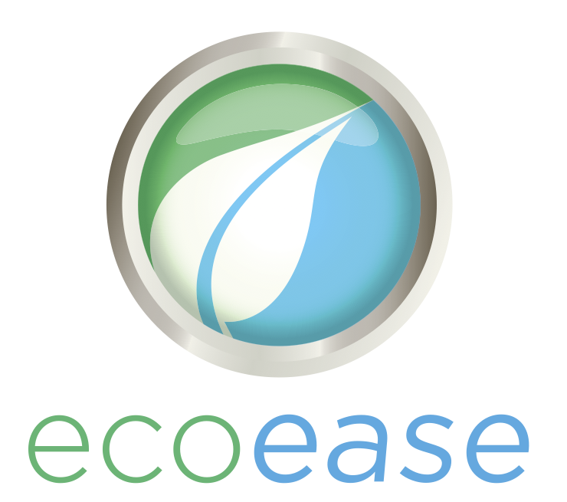

Top 5 Things To Look For In A Solar Quote

When you compare solar quotes, it’s important to have a clear idea of what to look for, so that you can get a great outcome. Here are the top 5 things you should look for in a solar proposal.

#1: High Quality Solar Panels
Solar panel quality matters! Too often in Australia cheap panels are sold to unsuspecting customers who think they are getting a great deal based on price alone. Unbeknownst to them, cheaper panels may also come with defects such as discoloration, sealant failures, snail trails and even short circuits. These defects might not be obvious for the first few years. Sales people can be very convincing on how their panel is “the best in the world”. The truth is often as straight forward as “you get what you pay for”. A high quality solar panel is produced under strictly automated factory conditions. Care is taken at each step to ensure optimum quality. Often even a visual inspection can tell the difference between a quality solar panel and a cheap one. Quality products should last their full expected lifecycle of at least 30 years.
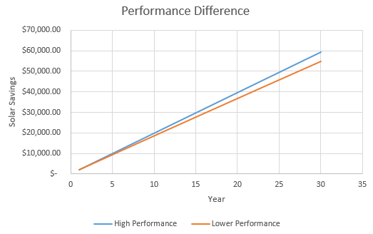

#2: Performance
Solar panel performance is one of the key things you should look for in a solar quote. A high performance solar panel can deliver as much as 10% more energy than a poor quality one! Over a solar panel’s lifecycle, this can work out to be a considerable amount of money in lost savings. A quick example:
This graph shows the difference between a higher quality system versus a normal system (5kW) (assuming both reach their expected lifecycle of 30 years. You can see that the difference in savings is over $4,700!

#3: Reliability
A good solar system should work seamlessly. It’s important to choose quality components to ensure maximum reliability. Every electronic device has some expected failure rate. It’s no different with solar panels and inverters. Solar panels should be a reputable (well-known) brand and inverters should be either European made or a Chinese company with an excellent reputation.

#4: Reputation
This is perhaps one of the most important things to consider when comparing solar quotes. It doesn’t take much to find out the reputation of a solar panel, solar company or inverter. Just do a quick Google search for “[solar brand] reviews”. But, beware! Reputation management is something that some companies spend a lot of money on – this means there are companies out there who deliberately mislead customers about their reputation. Be sure to read any reviews they claim and hold independent websites with a higher regard than self-managed reviews. Forums can be a good place to look however even they aren’t immune to vested-interests.

#5: Warranties
If anything goes wrong with your solar system, you want a good, solid warranty in place. Some things to consider:
- Is the warranty reasonable?
- Will the warranty be honoured?
- Where are the companies who warrant the products based?
- Are there any third party warranties applicable and how do they work?
It’s very important to know the answer to all of these questions before you choose a solar provider.

Contact Eco Ease Today to find out how our High Performance Solar packages can help you save!

